**ENTEBBE KINGS SECONDARY SCHOOL**

**END OF TERM TWO**

**BIOLOGY EXAM FOR SENIOR TWO**

**TIME: 1HOUR 30 MINUTES**

**Name** ……………………………………………………………….**signature**……………………

***Instructions:*** Attempt all items in the spaces provided.

**Item 1.**

During the course of the term, there have been increasing cases of dental diseases amongst students which raised a lot of worries in the school community. Some students started starving with the fear to serve food prepared from the school kitchen claiming that, the problem could be escalating from how food is prepared. Some students proposed that, the school administration should shift from serving them with beans to meat since beans could be containing some aflatoxins causing teeth decay. While other students resorted to canteen junk foods.

***Support material showing a student under oral examination by the dentist.***

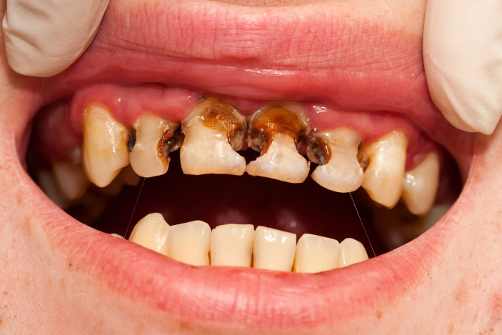

**Task**

You have been approached by the dean of students (D.O.S) requesting you to sensitize your fellow students about this issue. He requested you to put much emphasis on the causes, oral hygiene and other health risks likely to develop if they (students) failed to mind about proper oral hygiene. (15scores).

……………………………………………………………………………………………………………………………………………………………………………………………………………………………………………………………………………………………………………………………………………………………………………………………………………………………………………………………………………………………………………………………………………………………………………… ………………………………………………………………………………………………………………………………………………………………………………………………………………………………………………………………………………………………………………………………………………………………………………………………………………………………………………………………………………………………………………………………………………………………………………

………………………………………………………………………………………………………………………………………………………………………………………………………………………………………………………………………………………………………………………………………………………………………………………………………………………………………………………………………………………………………………………………………………………………………………

………………………………………………………………………………………………………………………………………………………………………………………………………………………………………………………………………………………………………………………………………………………………………………………………………………………………………………………………………………………………………………………………………………………………………………

………………………………………………………………………………………………………………………………………………………………………………………………………………………………………………………………………………………………………………………………………………………………………………………………………………………………………………………………………………………………………………………………………………………………………………

………………………………………………………………………………………………………………………………………………………………………………………………………………………………………………………………………………………………………………………………………………………………………………………………………………………………………………………………………………………………………………………………………………………………………………

**Item2**.

At the start of July 2024, we experienced hot climatic conditions that resulted into water scarcity for both domestic and agricultural use. **HAKIM** a prominent vegetable grower in **Entebbe** reacted to the condition and opted to buy water for watering his tomato nursery beds from **GREENS FARMERS’ SUPPLIES CENTER** located at **ABAITA ABABIRI**. One day, after watering his two nursery beds (**A and B**) using water from two jerrycans he had bought, he realized that the tomato seedlings in nursery bed **A** looked fresh, with strong and up-right stems. While those in nursery bed **B**, stems became bent (curved downwards/soft) and had dropping leaves. Hakim was challenged and became worried about the loss he had yet conceded. He quickly ran to the agriculture officer for help. The officer decided to collect the samples of water which Hakim had left in jerrycans that watered nursery beds **A** and **B**. In collaboration with Nkumba university department of Agriculture and fisheries, laboratory tests on collected water samples were carried out using two potato cylinders of length **3cm**. During experimentation, Dr. Bossa put each potato cylinder into glass beakers labeled **A** and **B** in correspondence to the **100cm3** of water samples **A** and **B**. After **8hours** of experimentation, Dr. Bossa started to record the results in the table as shown below. However, he got an emergency call that required him to take the university football team to FUFA for verification, thereby submitting unfinished research. As an experienced researcher, he advised the agriculture officer to carry the research work to the biology/agriculture department at Entebbe kings secondary school for help.

**Table**

|  |  |  |  |  |  |
| --- | --- | --- | --- | --- | --- |
| Water samples/100cm3 | Initial length/cm | Final length/cm | Change in length/cm | Texture of cylinders after 8hours | Appearance of the cylinders after 8hours |
| A | 3.0 | 3.3 |  |  |  |
| B | 3.0 | 2.6 |  |  |  |

**Task.**

You have been approached by your Biology teacher and advised to apply the knowledge and skills obtained during class lessons on movement of materials in and out of the cell, in order to assist the agriculture officer have a completed research. You should consider the following;

a). complete the table above. (04 scores)

b). suggest the experimentation/research

i). Aim. (01 score)

………………………………………………………………………………………………………………………………………………………………………………………………………………………………………………………………………………………………………………………………………………

ii). Hypothesis. (01score)

………………………………………………………………………………………………………………………………………………………………………………………………………………………………………………………………………………………………………………………………………………..

C). Research result analysis/explanation.

**Water sample A** (03scores)

………………………………………………………………………………………………………………………………………………………………………………………………………………………………………………………………………………………………………………………………………………………………………………………………………………………………………………………………**water sample B** (03 scores) ………………………………………………………………………………………………………………………………………………………………………………………………………………………………………………………………………………………………………………………………………………………………………………………………………………………………………………………………

d). suggest a conclusion/recommendation to HAKIM on what water sample he should use to continue watering his seedlings for proper growth. (04scores).

………………………………………………………………………………………………………………………………………………………………………………………………………………………………………………………………………………………………………………………………………………………………………………………………………………………………………………………………

e). identify the variables which Dr. Bossa considered during laboratory tests;

i). independent variable(s) (01score)

……………………………………………………………………………………………………………

ii).dependent variable(s) (01score)

……………………………………………………………………………………………………………..

ii). Controlled for variables(s) (02scores)

……………………………………………………………………………………………………………..

**Item 3.**

In essence to understand the effect of different foods we eat on our health, **JASPER** and **YAWA,** who are students in form two, took measurements of **height (m**) and **weight (kg)** of two students **X** and **Y.** Then after, they compared their results with the standard body mass index (**BMI**) courtesy of World Health Organization (**WHO**),their results were recorded in the table below.

|  |  |  |
| --- | --- | --- |
| **Student** | **Weight/kg** | **Height/m** |
| **X** | **58** | **1.97** |
| **Y** | **65** | **1.45** |

Standard body mass index (**BMI**)

|  |  |
| --- | --- |
| **Status** | **Range of values** |
| Underweight | Below 18 |
| Normal | 18 to 24.9 |
| Overweight | 24.9 to 29.9 |
| Obese | Above 30 |

**Task.**

Based on the above project findings, apply your skills, understanding and the knowledge obtained from nutrition studies, to show students **X** and **Y**, the likely health impact of their nutritional behavior. And advise them accordingly. (15scores)

………………………………………………………………………………………………………………………………………………………………………………………………………………………………………………………………………………………………………………………………………………………………………………………………………………………………………………………………………………………………………………………………………………………………………………………………………………………………………………………………………………………………………………………………………………………………………………………………………………………………………………………………………………………………………………………………………………………………………………………………………………………………………………………………………………………………………………………………………………………………………………………………………………………………………………………………………………………………………………………………………………………………………………………………………………………………………………………………………………………………………………………………………………………………………………………………………………………………………………………………………………………………………………………………………………………………………………………………………………………………………………………………………………………………………………………………………………………………………………………………………………………………………………………………………………………………………………………………………………………………………………………………………………………………………………………………………………………………………………………………………………………………………………………………………………………………………………………………………………………………………………………………………………………………………………………………………………………………………………………………………………………………………………………………………………………………………………………………………………………………………………………………………………………………………………………………………………………………………………………………………………………………………………………………………………………………………………………………………………………………………………………………………………………………………………………………………………………………………………………………………………………………………………………………………………………………………………………………………………………………………………………………………………………………………………………………………………………………………………………………………………………………………………………………………………………………………………………………………………………………………………………………………………………………………………………………………………………………………………………………………………………………………………………………………………………………………………………………………………………………………………………………………………………………………………………………………………………………………………………………………………………………………………………………………………………………Success